 | School of Computing  Third CIA Exam – Nov 2025  Course Code: INT317  Course Name: DATA MINING AND ANALYTICS  Duration: 90 minutes Max Mark: 50
PART A
Answer any FOUR of the following questions 4x10=40
1. Create the distance matrix between the following data points such as O1, O2, O3 and O4.
O1 | 12 | 23 | 12 | 23
O2 | 45 | 12 | 45 | 87
O3 | 12 | 45 | 21 | 45
O4 | 24 | 54 | 28 | 37

2. A database has five transactions. Let min sup = 60% and min.conf=80%.
Transaction id | Items
T100 | {N, P, O, L, F, Z}
T200 | {E, P, O, L, F, Z}
T300 | {N, B, L, F}
T400 | {N, V, D, L, F, Z}
T500 | {D, P, L, J, F}
- Find all frequent item sets using Apriori algorithm
- List all the strong association rules.
3. Compare Linear and Logistic regression. Derive the equation for sigmoid function in logistic regression.

4.Describe with suitable equations and diagrams, how ARIMA models overcome the limitations of ARMA models when applied to non-stationary time series data.

5.Create the dissimilarity matrix between the items using a simple distance measure based on the various forms of data. The ordinal traits are ranked as follows Excellent – 1, Average – 2, and Bad – 3.

Object | Attribute 1 (Nominal) | Attribute 2 (Ordinal) | Attribute 3 (Numerical)
O₁ | B1 | Excellent | 40
O₂ | B2 | Average | 55
O₃ | B1 | Bad | 72
O₄ | B3 | Excellent | 48

6. A bakery sells muffins at different prices each week. The baker records the price per muffin (x pence) and the number of muffins sold (y) during six consecutive weeks:

x(pence) | 12 | 18 | 24 | 30 | 36 | 42
y (sold) | 95 | 82 | 70 | 58 | 45 | 38
- Calculate the least square regression line y on x.
- Predict the number of muffins when he sells for 50
- Calculate the coefficient of determination R2

PART-B
Answer the following question 1x10=10
7. Find the covariance and correlation between the Stock Prices of Company A and Company B over a 6-month period:

Month | Company A stock price | Company B stock Price
Jan | 320 | 340
Feb | 350 | 360
Mar | 370 | 380
Apr | 390 | 400
May | 410 | 420
Jun | 430 | 440
School of Computing
Second CIA Exam – Sept 2025
Course Code: INT317
Course Name: DATA MINING AND ANALYTICS
Duration: 90 minutes Max Mark: 50
PART A
Answer any FOUR of the following questions 4x10=40
Q.No | Questions | CO | RBT Level
1 | Create the distance matrix between the following data points such as O1, O2, O3 and O4. | 4 | L3
  O1 | 12 | 23 | 12 | 23
  O2 | 45 | 12 | 45 | 87
  O3 | 12 | 45 | 21 | 45
  O4 | 24 | 54 | 28 | 37
2 | A database has five transactions. Let min sup = 60% and min.conf=80%.  - Find all frequent item sets using Apriori algorithm  - List all the strong association rules. | 2 | L3
  Transaction id | Items
  T100 | {N, P, O, L, F, Z}
  T200 | {E, P, O, L, F, Z}
  T300 | {N, B, L, F}
  T400 | {N, V, D, L, F, Z}
  T500 | {D, P, L, J, F}
3 | Compare Linear and Logistic regression. Derive the equation for sigmoid function in logistic regression. | 5 | L2
4 | Describe with suitable equations and diagrams, how ARIMA models overcome the limitations of ARMA models when applied to non-stationary time series data. | 6 | L2
5 | Create the dissimilarity matrix between the items using a simple distance measure based on the various forms of data. The ordinal traits are ranked as follows Excellent – 1, Average – 2, and Bad – 3. | 1 | L3
  Object | Attribute 1 (Nominal) | Attribute 2 (Ordinal) | Attribute 3 (Numerical)
  O₁ | B1 | Excellent | 40
  O₂ | B2 | Average | 55
  O₃ | B1 | Bad | 72
  O₄ | B3 | Excellent | 48
6 | A bakery sells muffins at different prices each week. The baker records the price per muffin (x pence) and the number of muffins sold (y) during six consecutive weeks:  - Calculate the least square regression line y on x.  - Predict the number of muffins when he sells for 50  - Calculate the coefficient of determination R2 | 3 | L3
  x(pence) | 12 | 18 | 24 | 30 | 36 | 42
  y (sold) | 95 | 82 | 70 | 58 | 45 | 38
PART B
Answer the following question 1x10=10

7 | Find the covariance and correlation between the Stock Prices of Company A and Company B over a 6-month period: | 6 | L3
  Month | Company A stock price | Company B stock Price
  Jan | 320 | 340
  Feb | 350 | 360
  Mar | 370 | 380
  Apr | 390 | 400
  May | 410 | 420
  Jun | 430 | 440

School of Computing
Third CIA Exam – Nov 2025
Course Code: INT317
Course Name: DATA MINING AND ANALYTICS
Duration: 90 minutes Max Mark: 50
PART A
Answer any FOUR of the following questions 4x10=40
1. Create the distance matrix between the following data points such as O1, O2, O3 and O4.
O1 | 12 | 23 | 12 | 23
O2 | 45 | 12 | 45 | 87
O3 | 12 | 45 | 21 | 45
O4 | 24 | 54 | 28 | 37
Answer:
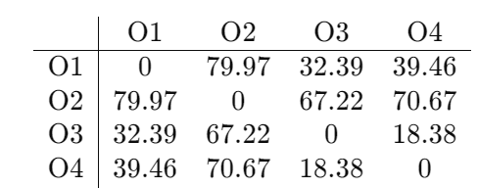
2. A database has five transactions. Let min sup = 60% and min.conf=80%.
Transaction id | Items
T100 | {N, P, O, L, F, Z}
T200 | {E, P, O, L, F, Z}
T300 | {N, B, L, F}
T400 | {N, V, D, L, F, Z}
T500 | {D, P, L, J, F}
- Find all frequent item sets using Apriori algorithm
- List all the strong association rules.
Answer:
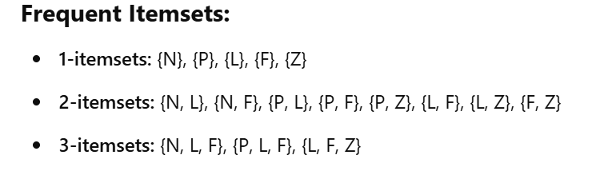
Strong Association rule:
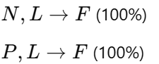

3. Compare Linear and Logistic regression. Derive the equation for sigmoid function in logistic regression.
Answer:
Comparison between linear and logistic regression (5 marks)

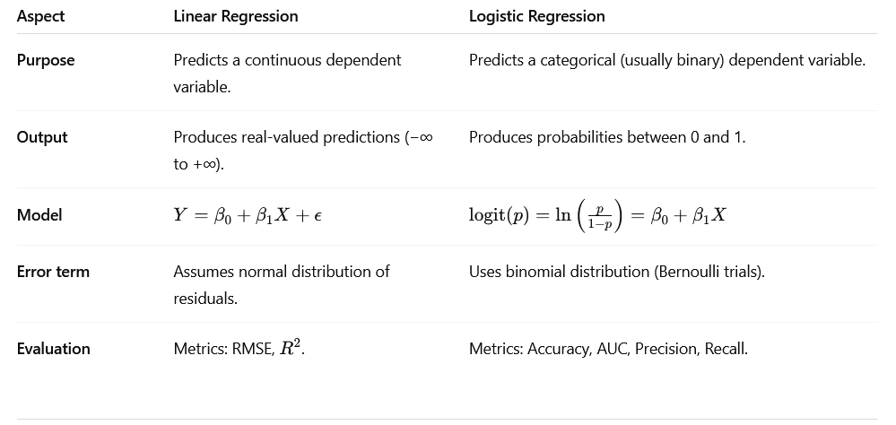

Derivation of Sigmoid function (5 marks)
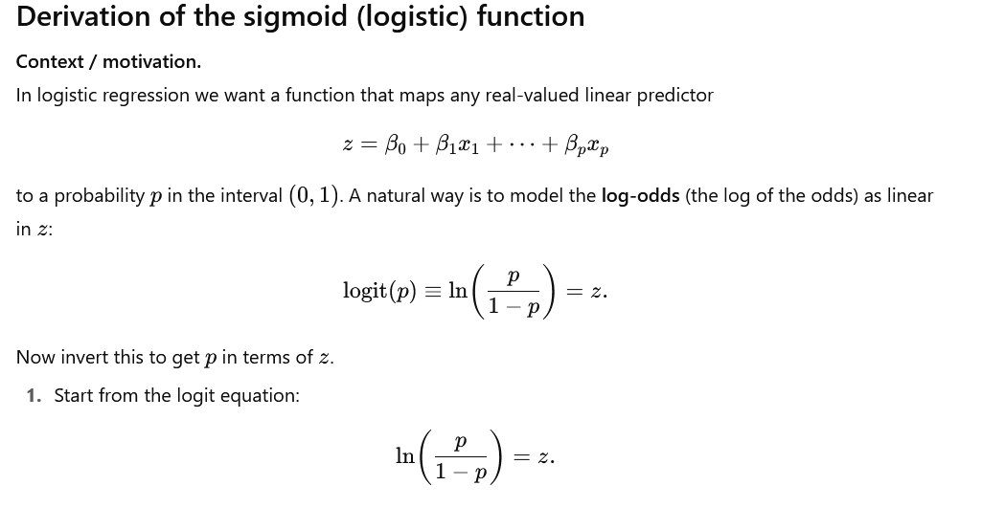
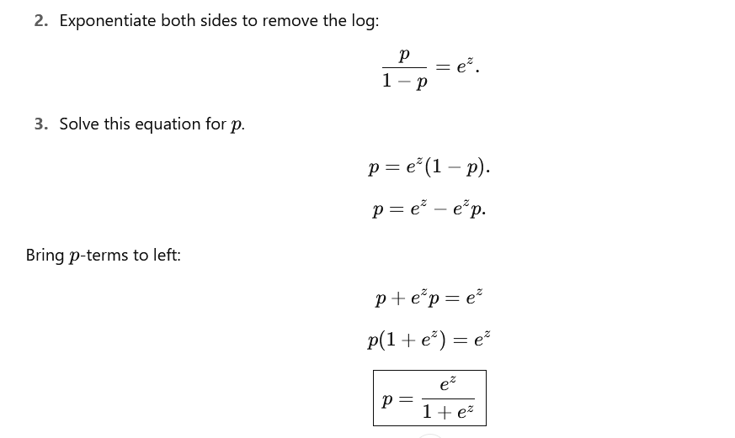
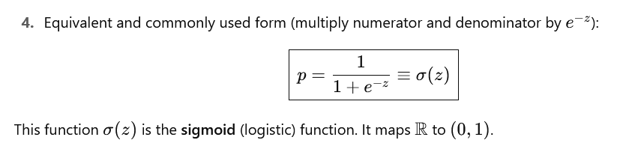

4.Describe with suitable equations and diagrams, how ARIMA models overcome the limitations of ARMA models when applied to non-stationary time series data.
Answer:
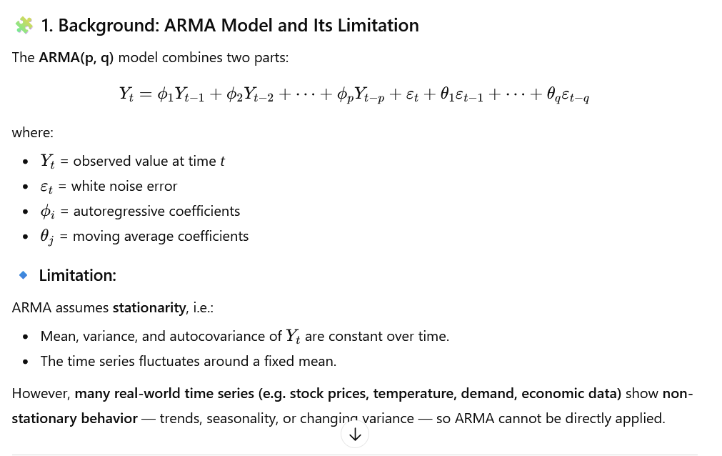
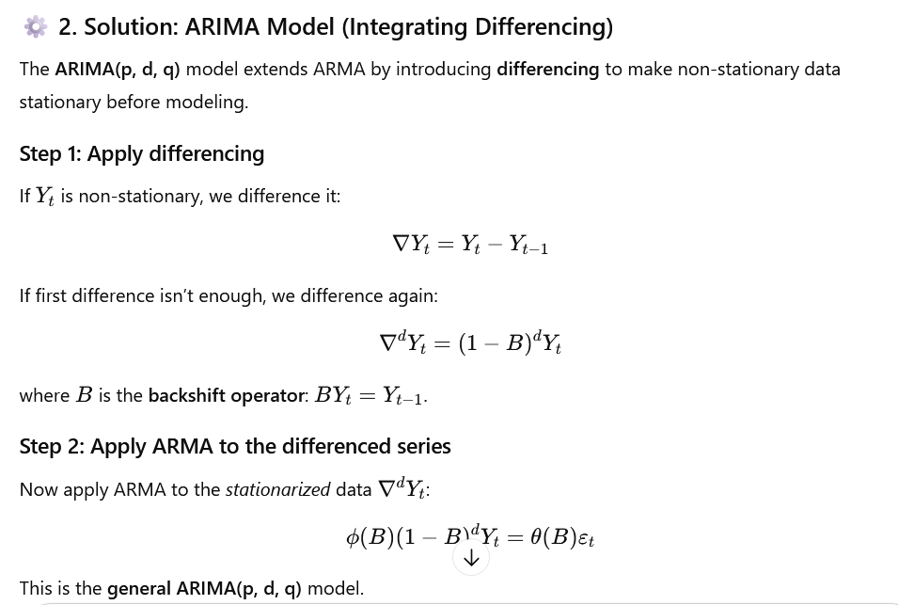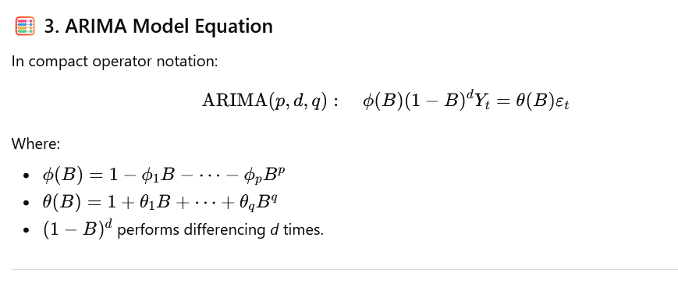
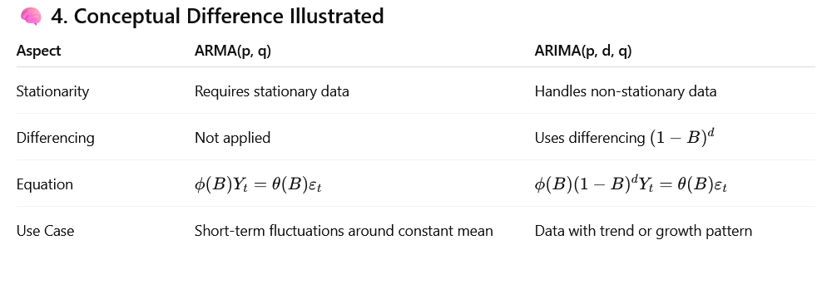
5.Create the dissimilarity matrix between the items using a simple distance measure based on the various forms of data. The ordinal traits are ranked as follows Excellent – 1, Average – 2, and Bad – 3.

Object | Attribute 1 (Nominal) | Attribute 2 (Ordinal) | Attribute 3 (Numerical)
O₁ | B1 | Excellent | 40
O₂ | B2 | Average | 55
O₃ | B1 | Bad | 72
O₄ | B3 | Excellent | 48
Answer:
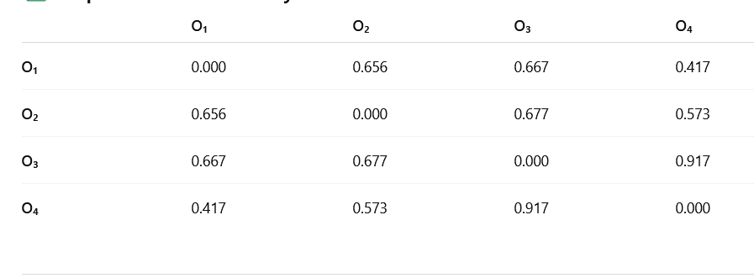

6. A bakery sells muffins at different prices each week. The baker records the price per muffin (x pence) and the number of muffins sold (y) during six consecutive weeks:

x(pence) | 12 | 18 | 24 | 30 | 36 | 42
y (sold) | 95 | 82 | 70 | 58 | 45 | 38
- Calculate the least square regression line y on x.
- Predict the number of muffins when he sells for 50
- Calculate the coefficient of determination R2
Answer:
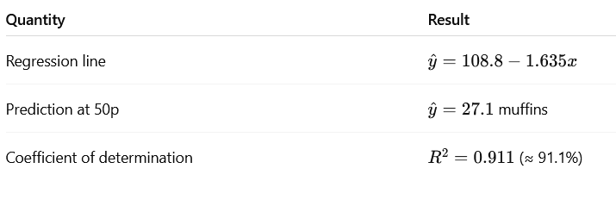

PART-B
Answer the following question 1x10=10
7. Find the covariance and correlation between the Stock Prices of Company A and Company B over a 6-month period:

Month | Company A stock price | Company B stock Price
Jan | 320 | 340
Feb | 350 | 360
Mar | 370 | 380
Apr | 390 | 400
May | 410 | 420
Jun | 430 | 440

Answer:
Covariance (5 Marks)
Covariance between Company A and Company A: 1616.67
Covariance between Company A and Company B: 1500.00
Covariance between Company B and Company B: 1400.00
Correlation (5 Marks)
Correlation between Company A and Company A: 1.00
Correlation between Company A and Company B: 0.997
Correlation between Company B and Company B: 1.00

